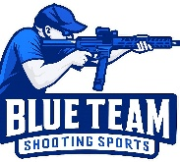
Blue Team Shooting Sports A.S.S.S. June 9th, 2026
COURSE DESIGNER: Ike Starnes

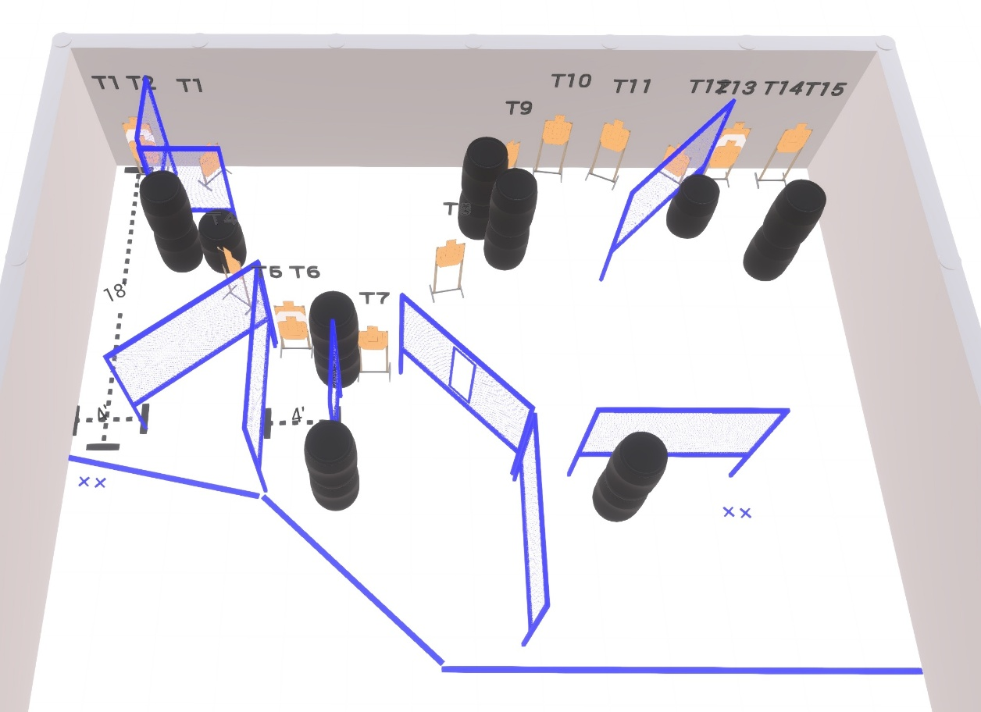

Written Stage Briefings:

Stage 1 – Where’s Ike? - is a 30-round, 150 point, Comstock Course. There are 15 cardboard targets and some noshoots. The best 2 hits per cardboard target will be scored.
Handgun start position Both feet on left Xs. The handgun is loaded and holstered, wrists below belt.
PCC start position Both feet on left Xs. PCC is loaded with stock touching belt.
On the audible start signal, engage targets from within the shooting area.

Stage 2 – When’s he coming back? - is a 30-round, 150 point, Comstock Course. There are 15 cardboard targets and some noshoots. The best 2 hits per cardboard target will be scored.
Handgun start position Both feet on right Xs. The handgun is unloaded and holstered, wrists below belt.
PCC start position Both feet on left Xs. PCC is unloaded with stock touching belt.
On the audible start signal, engage targets from within the shooting area.

